**Statement of Islamic Emirate regarding protection and preservation of ancient artifacts**

Date: February 20, 2021

in: [,](https://alemarahenglish.net/?cat=15), [Statements](https://alemarahenglish.net/?cat=8)

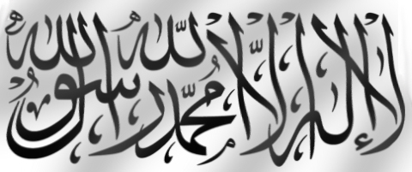

The Islamic Emirate instructs all officials, commissions/departments chiefs, provincial and district governors, military unit and group commanders, the Mujahideen and all compatriots to take into consideration the following vis-à-vis ancient artifacts found around the country:

– As Afghanistan is a country replete with ancient artifacts and antiquity, and that such relics form a part of our country’s history, identity and rich culture, therefore all have an obligation to robustly protect, monitor and preserve these artifacts.

– No one is allowed to excavate, transport and sell historic artifacts anywhere, nor to move it outside the country under some other name.

– All Mujahideen must prevent excavation of antiquities and preserve all historic sites like old fortresses, minarets, towers and other similar sites so to safeguard them from damage, destruction and decay.

– As the Commission for Cultural Affairs is tasked with the duty of guarding and preserving ancient artifacts, all departments of the Emirate especially the Military Commission, governors and other Mujahideen must coordinate and cooperate with the Cultural Commission in protecting these artifacts.

– All type of trade, contracts and transport and transfer of ancient goods is henceforth forbidden. No one should try to disturb such sites or think about using them for profit.

**Islamic Emirate of Afghanistan**

**08/07/1442 Hijri Lunar**

**02/12/1399 Hijri Solar                   20/02/2021 Gregorian**